**Lesson04 Nested Components in Angular 4**

**Notes:-**

**1-component in Angular allows us to create a reusable UI widget. A component can be used by any other component. Let's look at a simple example of nesting a component inside another component.**

**\*There is 2 components in angular 4:-**

**A-App Component** - This component is the root component and displays just the page header

**B-Employee Component** - This component is the child component and displays the Employee details table. This child component will be nested inside the root App Component

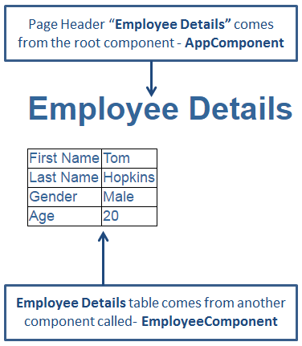

**Steps:-**

**1-we will create the component Employee**

import { Component, OnInit } from '@angular/core';

@Component({

selector: 'app-employee',

templateUrl: './employee.component.html',

styleUrls: ['./employee.component.css']

})

export class EmployeeComponent implements OnInit {

firstName:string;

lastName:string;

gender:string;

age:number;

constructor() {

this.firstName = 'Tom';

this.lastName = 'Hopkins';

this.gender = 'Male';

this.age = 20;}

ngOnInit() {

}}

**2-on the Employee.component.html we will write**

<table>

<tr>

<td>First Name</td>

<td>{{firstName}}</td>

</tr>

<tr>

<td>Last Name</td>

<td>{{lastName}}</td>

</tr>

<tr>

<td>Gender</td>

<td>{{gender}}</td>

</tr>

<tr>

<td>Age</td>

<td>{{age}}</td>

</tr>

</table>

**3-AppModule is the root module which bootstraps and launches the angular application. You can name it anything you want, but by convention it is named App Module.**

**\*It imports 2 system modules - BrowserModule and NgModule**

**1-BrowserModule - Every application that runs in a browser needs this module. In a later video in this course we will discuss NgIf and NgFor directives which are also provided by this module.**

**2-NgModule - @component decorator adds metadata to an angular component class, similarly @NgModule decorator adds metadata to the angular module class.**

import { BrowserModule } from '@angular/platform-browser';

import { NgModule } from '@angular/core';

import { AppComponent } from './app.component';

import{RouterModule,Route, Router} from '@angular/router';

import { EmployeeComponent } from './Components/employee/employee.component';

const appRoutes = [

// {path:"",component:HomeComponent},

]

@NgModule({

declarations: [

AppComponent,

EmployeeComponent

],

imports: [

BrowserModule,

RouterModule.forRoot(appRoutes)

],

providers: [],

bootstrap: [AppComponent]

})

export class AppModule { }

**Properties of the @NgModule decorator**

**1-Imports - Imports the BrowserModule required for an angular application to run in a web browser**

**2-Declarations - Contains the components registered with this module. In our case we have two - AppComponent and EmployeeComponent**

**3-Bootstrap - Contains the root component that Angular creates and inserts into the index.html host web page**

**4-on the app.Component.ts we will write the following code**

import { Component } from '@angular/core';

@Component({

selector: 'app-root',

template: '<div> <h1>{{pageHeader}}</h1> <app-employee></app-employee> </div>',

styleUrls: ['./app.component.css']

})

export class AppComponent {

title = 'app';

pageHeader: string = 'Employee Details';

}